Welcome to Cornerstone Church!
Sunday, October 19, 2014 10:00 a.m.
Welcome! We are so glad you chose to spend your Sunday with us.

Chiming of the Trinity
Word of Welcome! “God is Good! All the Time!” Reverend Cromie
Bringing in the Light
Presentation of the Bible
Call to Worship (Adapted from The Scots Confession, Ch 1)
Reverend Cromie
Praise Songs “Awesome God,” “Alive”
Director of Music, Susan Rovira
Call to Confession Bob Wegner
Unison Prayer of Confession Bob Wegner
Declaration of God’s Love and Forgiveness Bob Wegner
Congregational Response “Have Thine Own Way Lord”
Ritual of Friendship (print your name in Friendship Pad) Lisa Capurso
Announcements Reverend Cromie
A Moment for Celebration of Harmony Road Reverend Cromie
Time for Children and Children’s Offering* Wendy Barone
Joys & Concerns Bob Wegner
Prayers of the People followed by the Lord’s Prayer Reverend Cromie
Time of Greeting (Please say hello to your neighbor) Lisa Capurso
Hymn “Jesus Calls Us”
Affirmation of Faith - Belhar Confession (1982) Lisa Capurso
Introduction to the Offertory Lisa Capurso
Offertory Cornerstone Choir
Congregational Response “Give Thanks”
Prayer of Dedication Lisa Capurso
Old Testament Scripture: Psalm 37:1-9 Bob Wegner
New Testament Scripture: Acts 5:17-32 Reverend Cromie
Meditation: Acts Sermon Series Week 5 Reverend Cromie
“Obey God Vs. Human Authority"
Hymn “Take Time to be Holy”
Benediction (Please join hands in a circle.) Reverend Cromie

* Children may leave for Sunday School.
Next Sunday, October 26th, is Reformation Sunday and we will continue a Sermon Series on the book of Acts called We are the Church. The sermon will be “The Face of an Angel,” based on Acts 6, and Communion will be served. Children are welcome to come to church in costumes! Join us - all are welcome!

The Ocean County CROP Walk is TODAY – it’s not too late to join us! We will have a team from Cornerstone participating once again - we will meet at the Presbyterian Church of Toms River at 1:30 PM. Please consider walking OR sponsoring our team. Registration forms are available – see Wendy Barone or Elizabeth Hughes.

The Youth will meet after worship today for the CROP Walk! Anyone participating in the event is welcome to go with us to lunch prior to heading over to The Toms River Presbyterian Church to start the walk. If you're not walking please consider sponsoring another youth group member! Contact Wendy Barone at 732-299-4390 or Pastor Courtney if you have any questions about Youth Group.

Operation Christmas Child – deadline for boxes is NEXT Sunday! We are participating in Operation Christmas Child where we pack shoeboxes as gifts for children in need around the world, and asking members of our congregation to take a box home to fill – see Elizabeth Hughes to get one or more boxes! Refer to the brochure that comes with your box for instructions. Return filled boxes to church by Sunday, October 26! If you are able, please include $7 for shipping when you return your box (cash or check made payable to Cornerstone). Also, we will be collecting bars of soap, hair brushes, combs, and washcloths throughout October. Thank you!!

Our Thanks to our Elders as Members of our Session
2014: Dominique Robert, Todd Moyer, Kellie Pushko, Bruce Thompson
2015: Lisa Capurso, David LaCross, Gail Carlson, Wendy Barone
2016: Tina Kas, Patti Miller, Sharron A. Smith (Clerk of Session)
Next meeting: November 19th at 7:20 PM at Jackson United Methodist Church

Our Board of Deacons – thank you for your service!
2014: David Carlson, Sueli Paes de Barros
2015: Laurie Wegner
2016: Donna Rosato, Betty Thompson
Next meeting: November 19th at 7:20 PM at Jackson United Methodist Church

Pastor: Courtney Cromie, 732-928-2424, or 561-703-2263
Director of Music: Susan Rovira, 609-371-1473
Part-time Youth Director: Wendy Barone, 732-299-4390
Director of Christian Education: Kristen DiGirolamo, 732-657-7808
Treasurer: Tina Kas, 732-928-1778
Administrative Secretary: Elizabeth Hughes, 732-833-6857
Nursery Care: Courtney Miner
We will have our first “Work Day” at the church on Harmony Road on Sunday, October 26th after worship! Join with us and a team from the Presbyterian Church of Toms River as we begin work on our new home. See the insert for specifics on what is needed for the day. For those that would like to support this project and future work days but may not be able to help with the physical labor, we welcome donations of Home Depot gift cards! Talk to Bruce Thompson for more information.

Trunk or Treat will be on Sunday, October 26th at 6:00 PM (setup at 4:30) at DeBows! All are welcome! There will be activities and games for children, snacks, and “trunk or treating” with prizes for the best decorated trunks! Please talk to Pastor Courtney for more information.

Tuesday morning Women’s Bible Study meets every Tuesday morning from 10:30 AM – 12:15 PM. The group is led by Pastor Courtney and meets at the home of Elizabeth Hughes. The women are doing a 10-week Beth Moore DVD Study called The Patriarchs: Encountering the God of Abraham, Isaac, and Jacob. All women welcome!

The Adult Book Study meets on Monday evenings and is continuing their study of the book Twelve Ordinary Men. This group meets at 6:30 PM at the home of Bob & Laurie Wegner. All adults are encouraged and welcome!

We have raised more than $10,000 through our ongoing Shop Rite Gift Card fundraiser! Gift cards are available for you to purchase each Sunday before worship, and 5% of the purchase price goes directly to the church. Thanks to all, we have raised $10,250 for the Foundation Fund. For more information, contact Vernice DaConceicao.

Volunteers scheduled for Sunday, October 26th:
  - Set-up: The LaCross Family
  - Greeters: Marye Barbagallo, Wendy Barone
  - Communion Preparation: The Moyer Family
  - Communion Servers: Tina Kas, Sharron Smith, Patti Miller

Cornerstone Meets at McAuliffe Middle School
35 South Hope Chapel Road, Jackson
www.cornerstonechurchofjackson.org
Mailing Address: P.O. Box 140, Jackson, NJ 08527
    - E-mail: pastor@cornerstonechurchofjackson.org

Cornerstone Presbyterian Church

A place where you can be who you are.

“Building Community on the Solid Rock of Jesus Christ”

Mission Statement:
We the people of Cornerstone
Are a part of God’s Grand Adventure to:
Ground our lives on the solid rock of Jesus Christ,
Build up each other in love through prayer, words and deeds,
And to create God’s community in Jackson and beyond.



Sunday October 19, 2014 10:00 a.m.
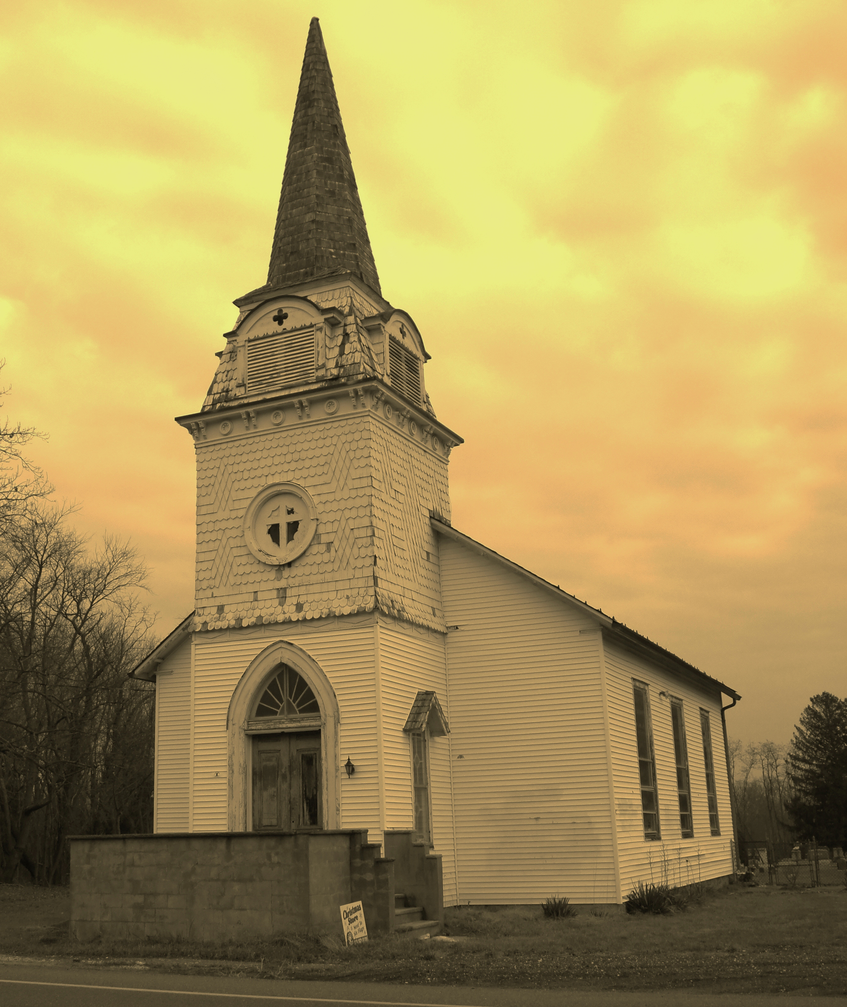
Workday at Harmony Road
October 26, 2014 after worship
(Lunch provided by Hope Cathedral)
Adults only!
See Bruce Thompson for more information!

The work will primarily be a combination of demolition and some work in the attic as follows:

1) Dismantle the outhouse.
2) Remove short wall in choir area.
3) Remove lower storm windows on sides as well as storm windows in back sides.
4) With scaffolding in place, scrap 2 small ceiling areas where moisture has affected the paint.
5) Remove carpeting in center aisle only.
6) Place plywood in attic for future renovation.
7) Install insulation in attic.
8) Repair Bilco door that leads to basement.
9) Remove dirt from basement to fill outhouse hole and help level and increase the basement floor.

Tools/Items needed:

1) Hammers, crowbars needed for outhouse and placing plywood in attic
2) Extension cords
3) Saw horses
4) Screwdrivers or small chisels
5) Gloves
6) Shovels and buckets for dirt removal
7) Tarps and masking tape
8) Ladders
9) We also need rolls of insulation (1200 sq ft of 8 inch), coffee cans for nails, plywood for the attic (9 4 by 8 pieces Cut in two), brackets for the basement door, An aluminum 4 by 8 sheet for basement door, exterior plywood at 3/4 inch, and We need stainless steel 6 inch hinges to replace the rusted ones if possible. We also need screwdrivers and scrapers on a stick to pull up carpet or wonder bars. We need screws and nails for plywood and bucket pails to move dirt from basement to the outhouse area. We also welcome donations of Home Depot gift cards!
Workday at Harmony Road
October 26, 2014 after worship
Adults only!
(Lunch provided by Hope Cathedral)
See Bruce Thompson for more information!

The work will primarily be a combination of demolition and some work in the attic as follows:

1) Dismantle the outhouse.
2) Remove short wall in choir area.
3) Remove lower storm windows on sides as well as storm windows in back sides.
4) With scaffolding in place, scrap 2 small ceiling areas where moisture has affected the paint.
5) Remove carpeting in center aisle only.
6) Place plywood in attic for future renovation.
7) Install insulation in attic.
8) Repair Bilco door that leads to basement.
9) Remove dirt from basement to fill outhouse hole and help level and increase the basement floor.

Tools/Items needed:

1) Hammers, crowbars needed for outhouse and placing plywood in attic
2) Extension cords
3) Saw horses
4) Screwdrivers or small chisels
5) Gloves
6) Shovels and buckets for dirt removal
7) Tarps and masking tape
8) Ladders
9) We also need rolls of insulation (1200 sq ft of 8 inch), coffee cans for nails, plywood for the attic (9 4 by 8 pieces Cut in two), brackets for the basement door, An aluminum 4 by 8 sheet for basement door, exterior plywood at 3/4 inch, and We need stainless steel 6 inch hinges to replace the rusted ones if possible. We also need screwdrivers and scrapers on a stick to pull up carpet or wonder bars. We need screws and nails for plywood and bucket pails to move dirt from basement to the outhouse area. We also welcome donations of Home Depot gift cards!

