Welcome to Cornerstone Church!
Communion Sunday, September 29, 2013 10:00 a.m.
Welcome! We are so glad you chose to spend your Sunday with us.

Chiming of the Trinity
Word of Welcome! “God is Good! All the Time!” Reverend Cromie
Bringing in the Light
Presentation of the Bible
Call to Worship Mary Gardiner
Praise Songs “In His Time,” “How Beautiful”
Director of Music, Susan Rovira
Call to Confession Reverend Cromie
Responsive Prayer of Confession Reverend Cromie
Declaration of God’s Love and Forgiveness Reverend Cromie
Congregational Response #316 “Breathe on Me, Breath of God”
Ritual of Friendship (print your name in Friendship Pad) Lisa Capurso
Announcements Reverend Cromie
Minute for Mission – Prison Ministry Wendy Barone
Affirmation of Faith (based on Ezekiel 36:24-28) Lisa Capurso
Joys & Concerns Lisa Capurso
Prayers of the People & The Lord’s Prayer Kathy Genus
Time for Children and Children’s Offering* Reverend Cromie
Time of Greeting Lisa Capurso
Hymn “Precious Lord”
Introduction to the Offertory Kathy Genus
Offertory Anthem “We Fall Down” Cornerstone Choir
Congregational Response “Doxology”
Prayer of Dedication Kathy Genus

Old Testament Scripture: Exodus 33:12-17 Mary Gardiner
New Testament Scripture: Matthew 4:1-11 Anthony Maimone
Meditation “Follow Jesus’ Footsteps: Teach” Anthony Maimone
Sacrament of Communion
Hymn “The Old Rugged Cross”
Benediction (Please join hands in a circle.) Anthony Maimone

* Children entering fourth grade and younger may leave for Children’s Church.
Today we celebrate the Sacrament of the Lord’s Supper. We invite each and every one, regardless of your background, to partake. The cups in the center of the tray are wine and the cups on the outer edges are grape juice. Please wait until we can all partake together. Our thanks to all who helped prepare and serve the elements.

Today we continue the sermon series "Follow Jesus' Footsteps." This series will focus on being called as "followers of Jesus in all ways." Jesus meets us where we are and asks us to change our course and journey down a new way. Let Jesus change your ways and change your life. Listen to the words, "follow me." Come and follow Jesus’ Footsteps! Next week, the focus will be “love” with a sermon by Pastor Courtney. Next Sunday is also World Communion Sunday, and communion will be served by intinction. Join us! All are welcome!

The Session of Cornerstone Presbyterian Church has called a Congregational Meeting for the start of worship today for the purpose of adding an elder to the Nominations Committee and to elect a chairperson.

Rally Day for Kids and Adults NEXT SUNDAY October 6th! We will begin a new year of Sunday School (during worship) for kids up through High School, and there will be a new ADULT class led by Anthony Maimone before worship at 9 AM with lessons focused on “improving interpersonal relationships” based on characters of the Bible.

Our Thanks to our Elders as Members of our Session
Clerk of Session: Sharron A. Smith
2013: Denise Mudalel, Lisa Capurso, Okoro Okparaeke, Chuck Calhoun
2014: Dominique Robert, Todd Moyer, Kellie Pushko, Bruce Thompson
2015: Barbara Dougherty, David LaCross, Gail Carlson, Wendy Barone
The next Session meeting is on Wednesday October 9th at 7 PM.

Our Board of Deacons – thank you for your service!
2013 Betty Thompson (Moderator), Laurie Wegner
2014 David Carlson, Sueli Paes de Barros
2015 Laura Stone

Pastor: Courtney Cromie, 732-928-2424, or 561-703-2263
Director of Music: Susan Rovira, 609-371-1473
Seminary Intern for Outreach, Mission and Evangelism: Kathy Genus, 732-585-3290
Pastoral Seminary Intern: Anthony Maimone, 732-722-8006
Part-time Youth Director: Mary Gardiner, 706-358-8128
Director of Christian Education: Kristen DiGirolamo, 732-657-7808
Treasurer: Tina Kas, 732-928-1778
Administrative Secretary: Elizabeth Hughes, 732-833-6857
Nursery Care: Courtney Miner
There will be a New Member Class after worship on Sunday, October 6th. Please come if you are interested in joining Cornerstone or even if you have questions and would like more information! Talk to Pastor Courtney for more information.

Children’s Ministry meets on the 2nd and 4th Thursdays of each month at DeBows Methodist Church from 6-7:30 PM. This group is for kids in K-6th grade, and is led by Pastor Courtney, Anthony Maimone, and Pastor Betty. Each meeting has a bible lesson, craft, snack, and games! The next meeting will be on October 10th. Also, SAVE THE DATE for Trunk or Treat on Sunday, October 27th! Please talk to Pastor Courtney or Anthony Maimone for more information.

The Adult Book Study will continue on Tuesday October 8th at 6:30 PM at the home of Bob & Laurie Wegner (no meetings this Tuesday). The study is based on the book One Thousand Gifts: A Dare to Live Fully Right Where You Are by Ann Voskamp. All adults are welcome!

The Cornerstone Choir rehearses on Thursdays at DeBows Methodist Church at 7:15 PM. All are welcome to join this fantastic group of people! Feel free to stop by rehearsal, or contact Susan Rovira, srplus3@comcast.net, for more information.

Shop Rite Gift Cards are available for you to purchase each Sunday before worship, and 5% of the purchase price goes directly to the church. Thanks to all, we have raised $9630 for the Foundation Fund. For more information, contact Vernice DaConceicao.

Tuesday morning Women’s Bible Study is led by Pastor Courtney and meets every Tuesday morning from 10:30 AM – 12:15 PM at the home of Elizabeth Hughes. The women are doing a Beth Moore DVD study called David: Seeking a Heart Like His. All women are welcome!

Volunteers scheduled for Sunday, October 6:
  - Set-up: Barbara Dougherty & Fred VanLooy
  - Greeters: Michele Calhoun, volunteer needed

Cornerstone Meets at McAuliffe Middle School
35 South Hope Chapel Road, Jackson
www.cornerstonechurchofjackson.org
Mailing Address: P.O. Box 140, Jackson, NJ 08527
    - E-mail: pastor@cornerstonechurchofjackson.org

Cornerstone Presbyterian Church

A place where you can be who you are.

“Building Community on the Solid Rock of Jesus Christ”

Mission Statement:
We the people of Cornerstone
Are a part of God’s Grand Adventure to:
Ground our lives on the solid rock of Jesus Christ,
Build up each other in love through prayer, words and deeds,
And to create God’s community in Jackson and beyond.

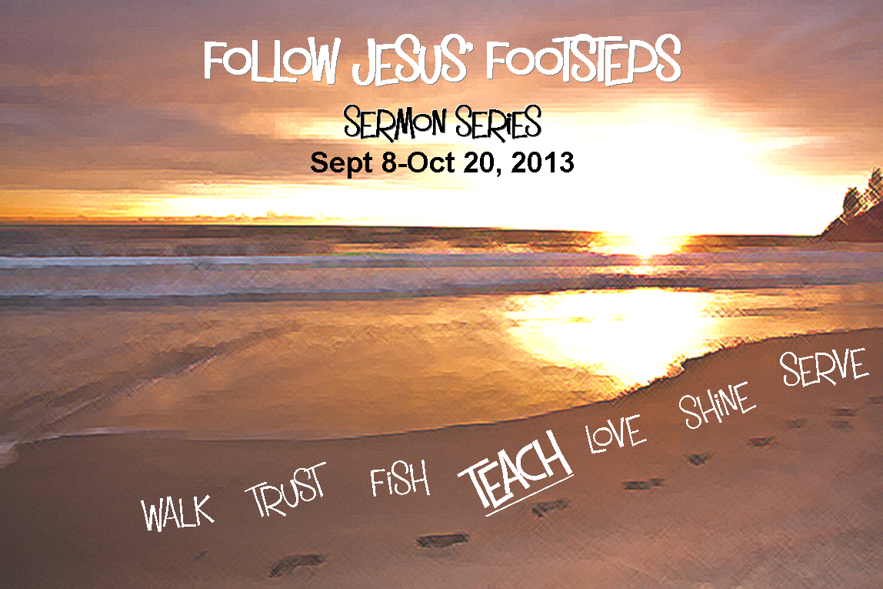

Sunday September 29, 2013 10:00 a.m.


Cornerstone Missions
Announcements

Shoe Collection through 10/20 As we seek to follow in Jesus' footsteps, we remember that He challenges us that when we see someone in need, we share what we have in response. During this sermon series, we encourage everyone to bring gently used and/or new shoes for any age so we can have others' make new footprints in much needed shoes. Speak to Wendy Barone or Pastor Courtney for more information.

Water Donations for Tent City As the urgent need for water at Tent City in Lakewood continues, we will continue to collect donations at church on Sunday mornings. Please bring your donations of cases or gallon jugs, and the worship committee will deliver them to Tent City. Please talk to Wendy Barone for more information.

Join us Sunday, October 13, 2013 for Volunteer Appreciation Sunday!

The Bible instructs us to be good stewards of our gifts and time. We recognize at Cornerstone Presbyterian that our ministry as a church will continue to build up the Kingdom of God but can only be done with the help of the many that continuously give of their time in service. As we continue to serve each other let us do so with love. We encourage and thank you all for your work and dedication to the Kingdom of God and to Cornerstone Presbyterian!

Stay after worship for a FREE concert by Frank Genus and his band at a tailgating party in the McAuliffe parking lot as well as a Potluck BBQ with hamburgers, hotdogs, sausage, and veggie burgers! If you are able, please bring a side dish, salad, or dessert! Please join us for a Wonderful Celebration! Signups for potluck items will be available at church.

Cornerstone Missions
Announcements

Shoe Collection through 10/20 As we seek to follow in Jesus' footsteps, we remember that He challenges us that when we see someone in need, we share what we have in response. During this sermon series, we encourage everyone to bring gently used and/or new shoes for any age so we can have others' make new footprints in much needed shoes. Speak to Wendy Barone or Pastor Courtney for more information.

Water Donations for Tent City As the urgent need for water at Tent City in Lakewood continues, we will continue to collect donations at church on Sunday mornings. Please bring your donations of cases or gallon jugs, and the worship committee will deliver them to Tent City. Please talk to Wendy Barone for more information.

Join us Sunday, October 13, 2013 for Volunteer Appreciation Sunday!

The Bible instructs us to be good stewards of our gifts and time. We recognize at Cornerstone Presbyterian that our ministry as a church will continue to build up the Kingdom of God but can only be done with the help of the many that continuously give of their time in service. As we continue to serve each other let us do so with love. We encourage and thank you all for your work and dedication to the Kingdom of God and to Cornerstone Presbyterian!

Stay after worship for a FREE concert by Frank Genus and his band at a tailgating party in the McAuliffe parking lot as well as a Potluck BBQ with hamburgers, hotdogs, sausage, and veggie burgers! If you are able, please bring a side dish, salad, or dessert! Please join us for a Wonderful Celebration! Signups for potluck items are available at church.

