Welcome to Cornerstone Church!
World Communion Sunday, October 6, 2013 10:00 a.m.
Welcome! We are so glad you chose to spend your Sunday with us.

Chiming of the Trinity
Word of Welcome! “God is Good! All the Time!” Reverend Cromie
Bringing in the Light
Presentation of the Bible
Opening Prayer Mary Gardiner
Call to Worship Anthony Maimone
Praise Songs “In the Singing,” “How Great is Our God”
Director of Music, Susan Rovira
Call to Confession Kathy Genus
Prayer of Confession Kathy Genus
Declaration of God’s Love and Forgiveness Kathy Genus
Congregational Response #316 “Breathe on Me, Breath of God”
Ritual of Friendship (print your name in Friendship Pad) Lisa Capurso
Announcements Reverend Cromie
Special Music “Here I Am, Lord” (in Spanish) Solo by Crystal Garcia
Service of Blessing of the Teachers Kristen DiGirolamo & Reverend Cromie
Time for Children and Children’s Offering* Anthony Maimone
Joys & Concerns Bob Wegner
Prayers of the People & The Lord’s Prayer Kathy Genus
Time of Greeting Lisa Capurso
Hymn #513 “Let Us Break Bread Together”
Affirmation of Faith (from United Church of Canada) Lisa Capurso
Introduction to the Offertory Anthony Maimone
Offertory Anthem “Siyahamba – We are Singing” Cornerstone Choir
Congregational Response “Doxology”
Prayer of Dedication Lisa Capurso
A Reading of Scripture, Mark 12:29-31, in Different Languages
Scripture in English: John 13:31-38 Reverend Cromie
Meditation “Follow Jesus’ Footsteps: Love” Anthony Maimone
Special Music “How Great Thou Art” solo by Crystal Garcia
Sacrament of Holy Communion Reverend Cromie
Hymn #377 “Lord, You Have Come to the Lakeshore”
Benediction (Please join hands in a circle.) Reverend Cromie

* Children in Kindergarten through High School may leave for Sunday School.
Today is World Communion Sunday and we celebrate the Sacrament of the Lord’s Supper with churches around the world in celebration of how we are one in The Father through Christ We invite each and every one, regardless of your background to partake. Communion today will be served by intinction. Please come forward by way of the center aisle, receive the bread, and dip it in the cup, and return to your seat by the outer aisle. If you prefer wine over juice, please go to the left of the communion table and wine will be available in the second chalice. If you wish to receive Communion, but cannot come forward, please signal an usher and you will be served in your seat. Our thanks to Patti Miller for preparing the elements.
Next week is Volunteer Appreciation Sunday and we will continue the sermon series "Follow Jesus' Footsteps" with a focus of “shine” and a sermon by Pastor Courtney. Stay after worship for a special tailgate party in the parking lot to celebrate our volunteers! In addition to a barbecue lunch, we will have Frank Genus’s band providing a free concert! If you are able to bring something to share, we ask that those with last names starting in A-G bring a salad or appetizer, and H-Z bring a dessert or beverage. JOIN US! All are welcome!

There will be a New Member Class after worship TODAY. Please come if you are interested in joining Cornerstone or even if you have questions and would like more information! Talk to Pastor Courtney for more information.

Our Thanks to our Elders as Members of our Session
Clerk of Session: Sharron A. Smith
2013: Denise Mudalel, Lisa Capurso, Okoro Okparaeke, Chuck Calhoun
2014: Dominique Robert, Todd Moyer, Kellie Pushko, Bruce Thompson
2015: Barbara Dougherty, David LaCross, Gail Carlson, Wendy Barone
The next Session meeting is on Wednesday October 9th at 7:30 PM at JUMC.

Our Board of Deacons – thank you for your service!
2013 Betty Thompson (Moderator), Laurie Wegner
2014 David Carlson, Sueli Paes de Barros
2015 Laura Stone

Pastor: Courtney Cromie, 732-928-2424, or 561-703-2263
Director of Music: Susan Rovira, 609-371-1473
Seminary Intern for Outreach, Mission and Evangelism: Kathy Genus, 732-585-3290
Pastoral Seminary Intern: Anthony Maimone, 732-722-8006
Part-time Youth Director: Mary Gardiner, 706-358-8128
Director of Christian Education: Kristen DiGirolamo, 732-657-7808
Treasurer: Tina Kas, 732-928-1778
Administrative Secretary: Elizabeth Hughes, 732-833-6857
Nursery Care: Courtney Miner
Today is RALLY DAY! This is the day that Sunday School resumes for children and adults. Our intern Anthony Maimone is teaching a class for adults before worship from 9-9:45 AM. Sunday School for children (K through High School) will be during 10 AM worship after the Time for Children. THANK YOU to our teachers: Anthony Maimone, Allyson Moyer, Kellie Pushko, Elizabeth Hughes, Courtney Miner (nursery), and our Director of Christian Education, Kristen DiGirolamo.

Children’s Ministry meets this Thursday 10/10 from 6-7:30 at DeBows with a lesson on Noah. The group typically meets on the 2nd and 4th Thursdays of each month. It is for kids in K-6th grade, and is led by Pastor Courtney, Anthony Maimone, and Pastor Betty. Each meeting has a bible lesson, craft, snack, and games! SAVE THE DATE for Trunk or Treat on Sunday, October 27th! Please talk to Pastor Courtney or Anthony Maimone for more information.

The Adult Book Study will continue on Tuesday October 8th at 6:30 PM at the home of Bob & Laurie Wegner. The study is based on the book One Thousand Gifts: A Dare to Live Fully Right Where You Are by Ann Voskamp. All adults are welcome!

The Cornerstone Choir rehearses on Thursdays at DeBows Methodist Church at 7:15 PM. All are welcome to join this fantastic group of people! Feel free to stop by rehearsal, or contact Susan Rovira, srplus3@comcast.net, for more information.

Shop Rite Gift Cards are available for you to purchase each Sunday before worship, and 5% of the purchase price goes directly to the church. Thanks to all, we have raised $9630 for the Foundation Fund. For more information, contact Vernice DaConceicao.

Tuesday morning Women’s Bible Study is led by Pastor Courtney and meets every Tuesday morning from 10:30 AM – 12:15 PM at the home of Elizabeth Hughes. The women are doing a Beth Moore DVD study called David: Seeking a Heart Like His. All women are welcome!

Volunteers scheduled for Sunday, October 13th:
  - Set-up: Ann Sarti
  - Greeters: Bruce & Betty Thompson

Cornerstone Meets at McAuliffe Middle School
35 South Hope Chapel Road, Jackson
www.cornerstonechurchofjackson.org
Mailing Address: P.O. Box 140, Jackson, NJ 08527
    - E-mail: pastor@cornerstonechurchofjackson.org

Cornerstone Presbyterian Church

A place where you can be who you are.

“Building Community on the Solid Rock of Jesus Christ”

Mission Statement:
We the people of Cornerstone
Are a part of God’s Grand Adventure to:
Ground our lives on the solid rock of Jesus Christ,
Build up each other in love through prayer, words and deeds,
And to create God’s community in Jackson and beyond.

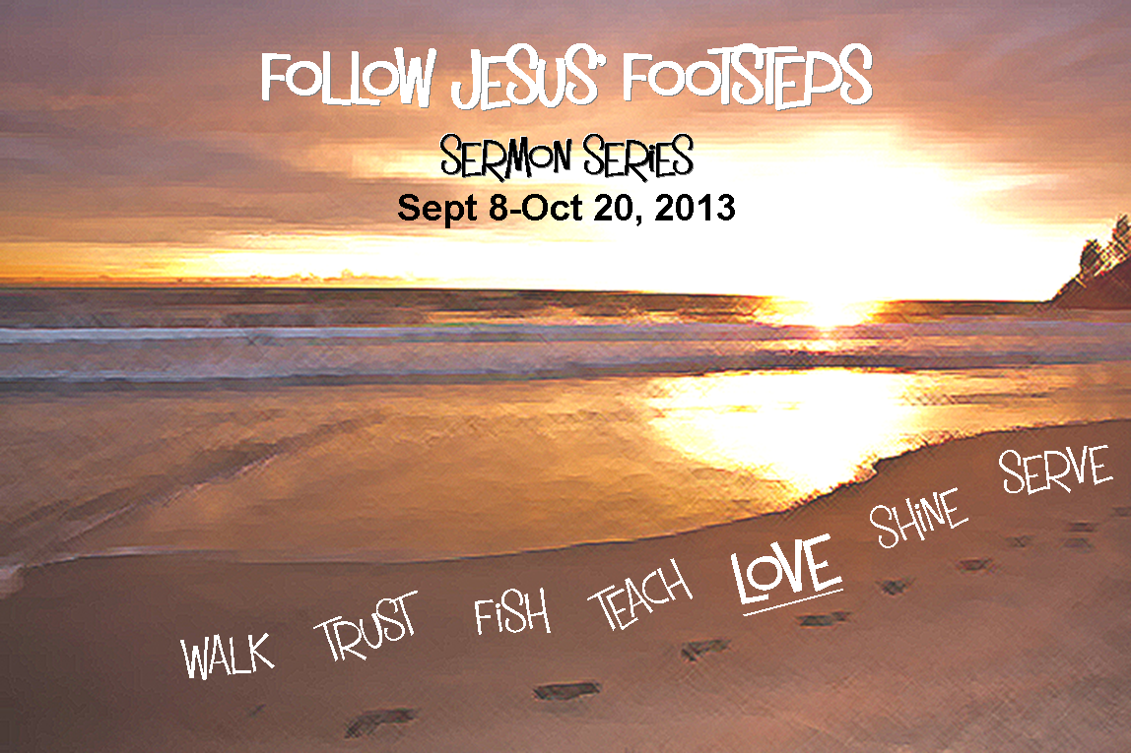

World Communion Sunday October 6, 2013 10:00 a.m.

Cornerstone Missions
Announcements


Shoe Collection through 10/20 As we seek to follow in Jesus' footsteps, we remember that He challenges us that when we see someone in need, we share what we have in response. During this sermon series, we encourage everyone to bring gently used and/or new shoes for any age so we can have others' make new footprints in much needed shoes. Speak to Wendy Barone or Pastor Courtney for more information.

Water Donations for Tent City Today is the last day that we will collect water donations for Tent City. THANK YOU to all who have donated throughout the summer, it has been greatly appreciated!

Samaritan’s Purse The Church Ladies have filled 79 boxes so far for "Operation Christmas Child." We are hoping to donate a total of 100! If you are able to fill a box, please see Joan Mallison. Several people already have taken boxes to fill - all boxes must be given to Joan Mallison by Sunday, October 27th. All families filling their own boxes may add in a letter and a picture. Each box costs $7.00 to mail. Even if you are unable to fill your own box, please consider making a donation to mail the boxes we already have filled! You can place your donation in the offering plate marked for “Samaritans Purse.” Please see Joan or Wendy if you have questions. THANK YOU!

Prison Ministry - Our Mission focus for the month of October is Prison Ministry. We are hoping to purchase 50 bibles to send to the women at the Edna Mahan Correctional Facility in New Jersey (they have to be a specific type to meet the safety requirements of the prison). We are also collecting composition notebooks for the women to use as prayer journals. If you are able to make a donation to this very important effort to bring God's Word to those in difficult circumstances, please see Wendy Barone.

We will be having a Church Garage Sale on Saturday, October 12th at the home of Lisa Capurso (1 Kindling Way) from 8 AM – 3 PM, with set up at 7:30 AM. We will be selling the household items that were recently donated to our church. If you have items that you would like to donate to the sale, or if you can HELP that day or to prepare on Friday afternoon, please contact Pastor Courtney!
Cornerstone Missions
Announcements

Shoe Collection through 10/20 As we seek to follow in Jesus' footsteps, we remember that He challenges us that when we see someone in need, we share what we have in response. During this sermon series, we encourage everyone to bring gently used and/or new shoes for any age so we can have others' make new footprints in much needed shoes. Speak to Wendy Barone or Pastor Courtney for more information.

Water Donations for Tent City Today is the last day that we will collect water donations for Tent City. THANK YOU to all who have donated throughout the summer, it has been greatly appreciated!

Samaritan’s Purse The Church Ladies have filled 79 boxes so far for "Operation Christmas Child." We are hoping to donate a total of 100! If you are able to fill a box, please see Joan Mallison. Several people already have taken boxes to fill - all boxes must be given to Joan Mallison by Sunday, October 27th. All families filling their own boxes may add in a letter and a picture. Each box costs $7.00 to mail. Even if you are unable to fill your own box, please consider making a donation to mail the boxes we already have filled! You can place your donation in the offering plate marked for “Samaritans Purse.” Please see Joan or Wendy if you have questions. THANK YOU!

Prison Ministry - Our Mission focus for the month of October is Prison Ministry. We are hoping to purchase 50 bibles to send to the women at the Edna Mahan Correctional Facility in New Jersey (they have to be a specific type to meet the safety requirements of the prison). We are also collecting composition notebooks for the women to use as prayer journals. If you are able to make a donation to this very important effort to bring God's Word to those in difficult circumstances, please see Wendy Barone.

We will be having a Church Garage Sale on Saturday, October 12th at the home of Lisa Capurso (1 Kindling Way) from 8 AM – 3 PM, with set up at 7:30 AM. We will be selling the household items that were recently donated to our church. If you have items that you would like to donate to the sale, or if you can HELP that day or to prepare on Friday afternoon, please contact Pastor Courtney!

