Welcome to Cornerstone Church!
Evangelism Sunday, September 22, 2013 10:00 a.m.
Welcome! We are so glad you chose to spend your Sunday with us.

Chiming of the Trinity
Word of Welcome! “God is Good! All the Time!” Lisa Capurso
Bringing in the Light
Presentation of the Bible
Call to Worship Anthony Maimone
Praise Songs “In My Life, Lord, Be Glorified” “In Christ Alone”
Director of Music, Susan Rovira
Responsive Call to Confession Mary Gardiner
Unison Prayer of Confession Mary Gardiner
Declaration of God’s Love and Forgiveness (from Psalm 103:12)
Mary Gardiner
Congregational Response #345 “Dear Lord and Father of Mankind”
Ritual of Friendship (print your name in Friendship Pad) Lisa Capurso
Announcements Kathy Genus
Affirmation of Faith: Philippians 2:6-11 Lisa Capurso
Testimony Okoro Okparaeke
Joys & Concerns Lisa Capurso
Prayers of the People & The Lord’s Prayer Anthony Maimone
Time for Children and Children’s Offering* Mary Gardiner
Time of Greeting Lisa Capurso
Hymn “Fishers of Men”
Introduction to the Offertory Lisa Capurso
Offertory Anthem “Down to the River to Pray” Cornerstone Choir
Congregational Response “Give Thanks”
Prayer of Dedication Lisa Capurso

Scripture Reading: Luke 5:1-11 Kathy Genus
Meditation “Follow Jesus’ Footsteps: Fish” Kathy Genus
Time for Commitment
Hymn “Will You Come and Follow Me”
Benediction (Please join hands in a circle.) Kathy Genus

* Children entering fourth grade and younger may leave for Children’s Church.
Today we continue the sermon series "Follow Jesus' Footsteps." This series will focus on being called as "followers of Jesus in all ways." Jesus meets us where we are and asks us to change our course and journey down a new way. Let Jesus change your ways and change your life. Listen to the words, "follow me." Come and follow Jesus’ Footsteps! Next week, the focus will be “teach” with a sermon by Anthony Maimone. Communion will be served. Join us! All are welcome!

The Session of Cornerstone Presbyterian Church has called a Congregational Meeting for September 29th for the purpose of adding an elder to the Nominations Committee and to elect a chairperson.

Upcoming Youth Group Events “Games and Gospel” TODAY at the Hughes’s home from 1:30-3:30 PM; visit to Trinity Presbyterian Church in East Brunswick after worship on Sunday 9/29. For more information on Youth Group, please talk to our Youth Director, Mary Gardiner, or Pastor Courtney.

Rally Day for Kids and Adults on October 6th! We will begin our 2013-2014 year of Sunday School (during worship) for kids up through Middle School, and there will be a new ADULT class led by Anthony Maimone before worship at 9:00 AM with lessons focused on “improving interpersonal relationships” based on characters of the Bible .

Our Thanks to our Elders as Members of our Session
Clerk of Session: Sharron A. Smith
2013: Denise Mudalel, Lisa Capurso, Okoro Okparaeke, Chuck Calhoun
2014: Dominique Robert, Todd Moyer, Kellie Pushko, Bruce Thompson
2015: Barbara Dougherty, David LaCross, Gail Carlson, Wendy Barone
The next Session meeting is on Wednesday October 9th at 7 PM.

Our Board of Deacons – thank you for your service!
2013 Betty Thompson (Moderator), Laurie Wegner
2014 David Carlson, Sueli Paes de Barros
2015 Laura Stone

Pastor: Courtney Cromie, 732-928-2424, or 561-703-2263
Director of Music: Susan Rovira, 609-371-1473
Seminary Intern for Outreach, Mission and Evangelism: Kathy Genus, 732-585-3290
Pastoral Seminary Intern: Anthony Maimone, 732-722-8006
Part-time Youth Director: Mary Gardiner, 706-358-8128
Director of Christian Education: Kristen DiGirolamo, 732-657-7808
Treasurer: Tina Kas, 732-928-1778
Administrative Secretary: Elizabeth Hughes, 732-833-6857
Nursery Care: Courtney Miner

There will be a New Member Class after worship on Sunday, October 6th. Please come if you are interested in joining Cornerstone, or even if you have questions and would like more information! Talk to Pastor Courtney for more information.

Children’s Ministry Meets THIS Thursday 9/26 from 6-7:30 at DeBows Methodist Church. This group is for kids in K-6th grade, and meets on the 2nd and 4th Thursday of each month, and is led by Pastor Courtney, Anthony Maimone, and Pastor Betty. Each meeting has a bible lesson, craft, snack, and games! This week the lesson will be on Miriam. Also, SAVE THE DATE for Trunk or Treat on Sunday, October 27th! Please talk to Pastor Courtney or Anthony Maimone for more information.

The Adult Book Study will continue on Tuesday October 8th at 6:30 PM at the home of Bob & Laurie Wegner (no meetings on the next 2 Tuesdays). The study is based on the book One Thousand Gifts: A Dare to Live Fully Right Where You Are by Ann Voskamp. All adults are welcome!

The Cornerstone Choir rehearses on Thursdays at DeBows Methodist Church at 7:15 PM. All are welcome to join this fantastic group of people! There will be NO rehearsal this Thursday, 9/26 – the next one will be on October 3rd. Feel free to stop by rehearsal, or contact Susan Rovira, srplus3@comcast.net, for more information.

Shop Rite Gift Cards are available for you to purchase each Sunday before worship, and 5% of the purchase price goes directly to the church. Thanks to all, we have raised $9630 for the Foundation Fund. For more information, contact Vernice DaConceicao.

Tuesday morning Women’s Bible Study is led by Pastor Courtney and meets every Tuesday morning from 10:30 AM – 12:15 PM at the home of Elizabeth Hughes. The women are doing a Beth Moore DVD study called David: Seeking a Heart Like His. All women are welcome!

Volunteers scheduled for Sunday, September 29:
  - Set-up: The Hughes Family
  - Greeters: George & Joan Nebel

Cornerstone Meets at McAuliffe Middle School
35 South Hope Chapel Road, Jackson
www.cornerstonechurchofjackson.org
Mailing Address: P.O. Box 140, Jackson, NJ 08527
    - E-mail: pastor@cornerstonechurchofjackson.org

Cornerstone Presbyterian Church

A place where you can be who you are.

“Building Community on the Solid Rock of Jesus Christ”

Mission Statement:
We the people of Cornerstone
Are a part of God’s Grand Adventure to:
Ground our lives on the solid rock of Jesus Christ,
Build up each other in love through prayer, words and deeds,
And to create God’s community in Jackson and beyond.

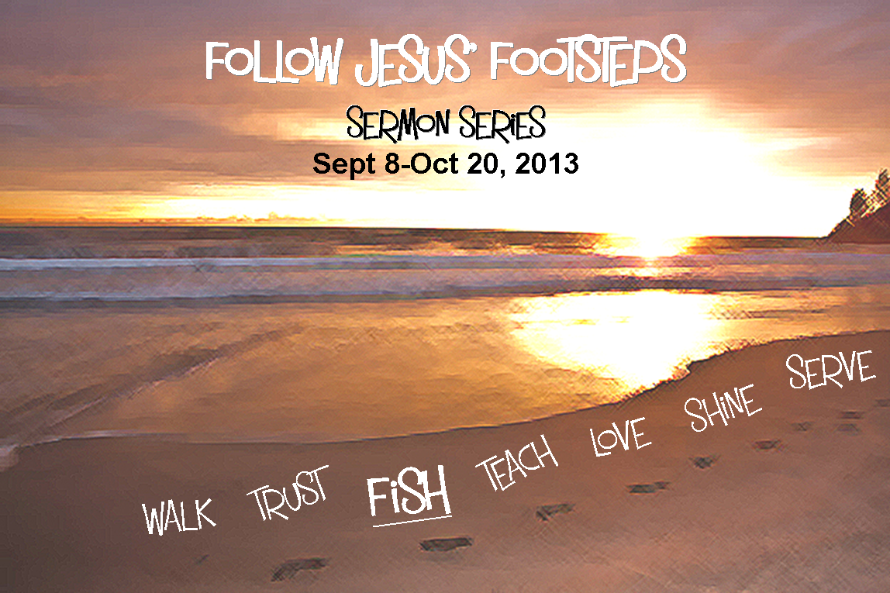

Evangelism Sunday September 22, 2013 10:00 a.m.
Field Trip to Trinity Presbyterian to Learn about How One Congregation Discerned Their Call to Become a GREEN Church
Sunday, September 29 from Noon - 4 PM

Kathy Genus has arranged for us to head up to Trinity Presbyterian in
East Brunswick - ALL ARE INVITED!

We will visit Trinity’s community garden and Butterfly Garden as well as meet with Debbie O'Halloran who encouraged Trinity to be a GREEN congregation. The Community garden was created by Alex Smith with an Eagle Scout project and it contains 38 – 10’x10’ plots, and is surrounded by sturdy fencing to keep the crops safe! The first years’ yielding has been amazing, and each and every gardener has been amazed and blessed by its success!

Everyone is invited to the home of Kathy and Frank for lunch following the tour.

Come learn more about helping to care for God's creation and discuss with us how we will go forward in having a building for Cornerstone and what we can do to pursue being a GREEN church!

Please RSVP to Pastor Courtney, Mary, or Kathy Genus.

Join us Sunday, October 13, 2013 for Volunteer Appreciation Sunday!

The Bible instructs us to be good stewards of our gifts and time. We recognize at Cornerstone Presbyterian that our ministry as a church will continue to build up the Kingdom of God but can only be done with the help of the many that continuously give of their time in service. As we continue to serve each other let us do so with love. We encourage and thank you all for your work and dedication to the Kingdom of God and to Cornerstone Presbyterian!

Stay after worship for a FREE concert by Frank Genus and his band at a tailgating party in the McAuliffe parking lot as well as a Potluck BBQ with hamburgers, hotdogs, sausage, and veggie burgers! If you are able, please bring a side dish, salad, or dessert! Please join us for a Wonderful Celebration! Signups for potluck items will be available on Sunday, September 29th.

Field Trip to Trinity Presbyterian to Learn about How One Congregation Discerned Their Call to Become a GREEN Church
Sunday, September 29 from Noon - 4 PM

Kathy Genus has arranged for us to head up to Trinity Presbyterian in
East Brunswick - ALL ARE INVITED!

We will visit Trinity’s community garden and Butterfly Garden as well as meet with Debbie O'Halloran who encouraged Trinity to be a GREEN congregation. The Community garden was created by Alex Smith with an Eagle Scout project and it contains 38 – 10’x10’ plots, and is surrounded by sturdy fencing to keep the crops safe! The first years’ yielding has been amazing, and each and every gardener has been amazed and blessed by its success!

Everyone is invited to the home of Kathy and Frank for lunch following the tour.

Come learn more about helping to care for God's creation and discuss with us how we will go forward in having a building for Cornerstone and what we can do to pursue being a GREEN church!

Please RSVP to Pastor Courtney, Mary, or Kathy Genus.

Join us Sunday, October 13, 2013 for Volunteer Appreciation Sunday!

The Bible instructs us to be good stewards of our gifts and time. We recognize at Cornerstone Presbyterian that our ministry as a church will continue to build up the Kingdom of God but can only be done with the help of the many that continuously give of their time in service. As we continue to serve each other let us do so with love. We encourage and thank you all for your work and dedication to the Kingdom of God and to Cornerstone Presbyterian!

Stay after worship for a FREE concert by Frank Genus and his band at a tailgating party in the McAuliffe parking lot as well as a Potluck BBQ with hamburgers, hotdogs, sausage, and veggie burgers! If you are able, please bring a side dish, salad, or dessert! Please join us for a Wonderful Celebration! Signups for potluck items will be available on Sunday, September 29th.


Cornerstone Missions
Announcements

The Missions Committee will have their next meeting on Wednesday, September 25th at 7:00pm at the home of Wendy Barone, 343 Brookfield Drive in Jackson. Please talk to Wendy for more information on the Mission Committee.

Shoe Collection through 10/20 As we seek to follow in Jesus' footsteps, we remember that He challenges us that when we see someone in need, we share what we have in response. During this sermon series, we encourage everyone to bring gently used and/or new shoes for any age so we can have others' make new footprints in much needed shoes. Speak to Wendy Barone or Pastor Courtney for more information.

Water Donations for Tent City As the urgent need for water at Tent City in Lakewood continues, we will continue to collect donations at church on Sunday mornings. Please bring your donations of cases or gallon jugs, and the worship committee will deliver them to Tent City. Please talk to Wendy Barone for more information.

Looking Ahead to October: Our mission focus for the month of October will be Prison Ministry. In worship next Sunday, September 29th, Wendy Barone will be talking in a Moment for Missions about how we can provide Bibles for the Edna Mahan Correctional Facility.

Cornerstone Missions
Announcements

The Missions Committee will have their next meeting on Wednesday, September 25th at 7:00pm at the home of Wendy Barone, 343 Brookfield Drive in Jackson. Please talk to Wendy for more information on the Mission Committee.

Shoe Collection through 10/20 As we seek to follow in Jesus' footsteps, we remember that He challenges us that when we see someone in need, we share what we have in response. During this sermon series, we encourage everyone to bring gently used and/or new shoes for any age so we can have others' make new footprints in much needed shoes. Speak to Wendy Barone or Pastor Courtney for more information.

Water Donations for Tent City As the urgent need for water at Tent City in Lakewood continues, we will continue to collect donations at church on Sunday mornings. Please bring your donations of cases or gallon jugs, and the worship committee will deliver them to Tent City. Please talk to Wendy Barone for more information.

Looking Ahead to October: Our mission focus for the month of October will be Prison Ministry. In worship next Sunday, September 29th, Wendy Barone will be talking in a Moment for Missions about how we can provide Bibles for the Edna Mahan Correctional Facility.

