Welcome to Cornerstone Church!
Sunday, April 21, 2013 10:00 a.m.
Welcome! We are so glad you chose to spend your Sunday with us.

Chiming of the Trinity Jonathan Hughes, Kayla Moyer, Julia Capurso
Word of Welcome! “God is Good! All the Time!” Reverend Cromie
Presentation of the Bible Call to Worship (adapted from Psalm 9:1,2) Kathy Genus
Praise Songs “Blessed Be Your Name,” “Here I Am to Worship)”
Director of Music, Susan Rovira

Call to Confession: Isaiah 30:15, 18, 19b Reverend Cromie
Unison Prayer of Confession Reverend Cromie
Declaration of God’s Love and Forgiveness: Colossians 1:11-14
Reverend Cromie
Congregational Response #426 “Lord, Speak to Me, That I May Speak” v. 5
Time for Children and Children’s Offering* Reverend Cromie
Ritual of Friendship (print your name in the Friendship Pad)
Worship Leader, Faron Trick
Announcements Reverend Cromie
Joys & Concerns Faron Trick
Prayers of the People & The Lord’s Prayer Kathy Genus
Time of Greeting (Please say hello to your neighbor) Faron Trick
Hymn #383 “My Faith Looks Up to Thee”
Responsive Affirmation of Faith: Adapted from Psalm 103:1-6
Faron Trick
Giving Thanks with our Offering of Gifts and Tithes Kathy Genus
Offertory Anthem “Be Still and Know” Cornerstone Choir
Congregational Response “Give Thanks”
Prayer of Dedication Faron Trick

New Testament Scripture: Matthew 18:21–35 Reverend Cromie
Meditation “Forgiveness: The Healing of Deep Wounds” Reverend Cromie
Hymn #324 “Open My Eyes That I May See ”
Benediction (Please join hands in a circle.) Reverend Cromie

* Children may leave for Sunday School.
Next Sunday, April 28th, Pastor Courtney will preach the sermon “Being Still and Observing Sabbath,” based on Genesis 2:1-3 and Psalm 46. Communion will be served. Join us! All are welcome!

The Open House at Pastor Courtney’s new home will be NEXT Sunday, April 28 from 12:45-3. Her address is 2567 Yardville Hamilton Square Rd., Apt 3, Hamilton Square, NJ. Please RSVP to Pastor Courtney if you plan to come!

Our Thanks to our Elders as Members of our Session
Clerk of Session: Sharron A. Smith
2013: Denise Mudalel, Lisa Capurso, Okoro Okparaeke, Chuck Calhoun
2014: Dominique Robert, Todd Moyer, Kellie Pushko, Bruce Thompson
2015: Barbara Dougherty, David LaCross, Gail Carlson, Wendy Barone
The next Session meeting will be on Wednesday, May 8th, at 7:00 PM.

Our Board of Deacons – thank you for your service!
2013 Betty Thompson (Moderator), Laurie Wegner
2014 David Carlson, Sueli Paes de Barros
2015 Jim Ryan, Laura Stone
Next Meeting – May 15th, 7:00 p.m. at the home of Betty Thompson.

Pastor: Courtney Cromie, 732-928-2424, or 561-703-2263
Director of Music: Susan Rovira, 609-371-1473
Intern from New Brunswick Seminary: Kathy Genus, 732-585-3290
Director of Christian Education: Kristen DiGirolamo, 732-657-7808
Treasurer: Tina Kas, 732-928-1778
Administrative Secretary: Elizabeth Hughes, 732-833-6857
Administrative Manager: Jim Ryan, 732-833-8514
Nursery Care: Patti Miller, 732-928-3212, Courtney Miner

Save the Date - Youth Sunday - May 12 – All middle school and high school kids are invited to participate in this special worship service run by the Youth! Youth - please talk to Pastor Courtney if you are available and willing to help!

Cornerstone Choir rehearsals are weekly on Thursday evenings, from 7 - 8:30 p.m. in the Sanctuary at DeBows Methodist Church. If you are a high school youth or adult who would like to participate in the choir, please contact Susan Rovira, 609-371-1473, srplus3@comcast.net.

Shop Rite Gift Cards are available for you to purchase each Sunday before worship, and 5% of the purchase price goes directly to the church. Thanks to all, we have raised $9270 for the Foundation Fund. For more information, contact Vernice DaConceicao.

The Adult Tuesday Evening Study continues on April 23rd at the home of Bob Wegner from 6:30-8:00 PM. The study is co-taught by Kathy Genus and Pastor Courtney, and is based on the book: Real Followers: A Radical Quest to Expose the Pretender Inside Each of Us by Michael Slaughter and Warren Bird. All adults welcome!

Women’s Tuesday Morning Bible Study meets from 10:30 AM – 12:15 PM at the home of Elizabeth Hughes and led by Pastor Courtney. The group is doing a Beth Moore study on the Book of James and the next meeting is on April 23rd. All women are welcome!

Pastor Emeritus Celebration, Fundraising Event – May 11, 5:00 PM at DeBows Methodist Church. Join us for a meal and entertainment as we celebrate the Pastor Emeritus status of Reverend Rob “Rev Rob” Morrison! Please let Lisa Capurso or Sharron Smith know if you are coming so that we can get a headcount by May 5. Admission is $10 for adults, $3 for children ages 3-12, and 2 and under are free.

Youth Girls Night May 10 – All girls in grades 5+ are invited to an evening of FUN and pampering: a light dinner, discussion on being created by God and self-esteem, facials and foot scrubs, and more! 6 – 8 PM at the Hughes’ home, 5 Kindling Way, Jackson.

VIP Water Walk: May 3-4th in Allentown. Cornerstone will once again be participating in the Villages in Partnership (VIP) Water Walk with Allentown Presbyterian Church. This is a 24-hour walk which raises money to provide clean water in Malawi, Africa. We would like to form a team of 12 people so that each volunteer will walk a 2-hour shift. We have three 2-hour slots left to fill! If you are interested, please sign up on the sheet that will be passed around during worship. If you cannot walk, please consider sponsoring one of our team members. Please contact Denise Mudalel or Pastor Courtney for more information or if you can be a sponsor.

Volunteers scheduled for next Sunday, April 28th:
  - Set-up: Mike Pushko
  - Greeters: Joan & George Nebel
  - Media Shout: Todd Moyer

Cornerstone Meets at McAuliffe Middle School
35 South Hope Chapel Road, Jackson
www.cornerstonechurchofjackson.org
Mailing Address: P.O. Box 140, Jackson, NJ 08527
    - E-mail: pastor@cornerstonechurchofjackson.org

Cornerstone Presbyterian Church

A place where you can be who you are.

“Building Community on the Solid Rock of Jesus Christ”

Mission Statement:
We the people of Cornerstone
Are a part of God’s Grand Adventure to:
Ground our lives on the solid rock of Jesus Christ,
Build up each other in love through prayer, words and deeds,
And to create God’s community in Jackson and beyond.

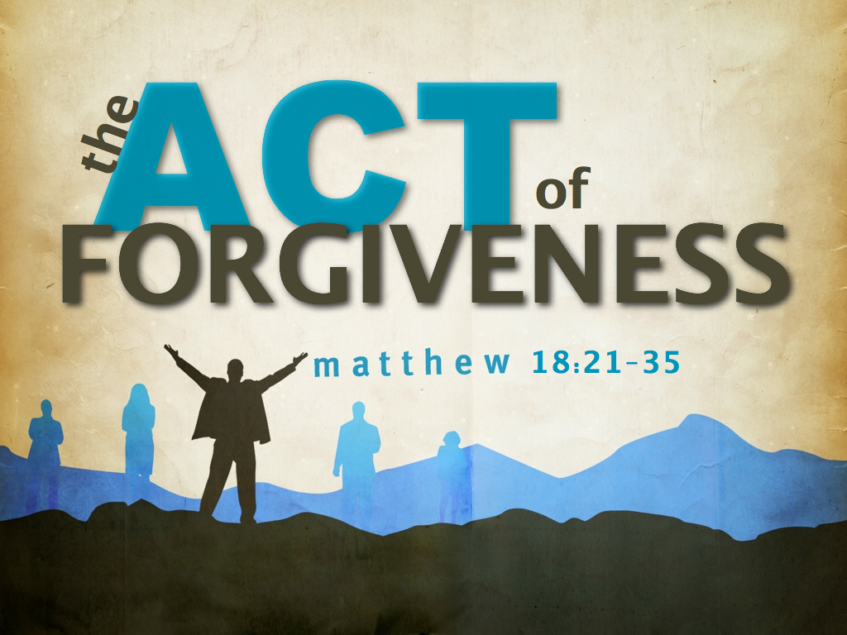

Sunday April 21, 2013 10:00 a.m.

